Market Monitor - Bangladesh - 2026-05

Highlights
The cost of the food basket in Bangladesh remained nearly stable in May, masking significant price volatility in key commodities. While the basket is considerably cheaper than a year ago, sharp and opposing monthly price movements in staples like onions and eggs suggest an unstable market.
The cost of a typical food basket increased slightly (↑0.6%) month-on-month to BDT 1,500.84, but remains 9.2% lower (↓9.2%) than the same period last year.
The monthly stability masks significant price volatility in essential goods. Onion prices plummeted (↓23.6%), alongside a sharp drop in chickpeas (↓17.0%). Conversely, the price of eggs surged (↑16.1%) during the same period.
Key market drivers this month include:
• Significant Annual Deflation: The overall food basket cost is down 9.2% year-on-year, primarily due to substantial price drops in sugar (↓52.3%), eggs (↓33.2%), and broiler chicken (↓31.3%).
• Sharp Monthly Price Corrections: Major price decreases in key staples, notably imported onions (↓23.6%) and chickpeas (↓17.0%), exerted strong downward pressure on the basket's cost this month.
• Persistent Inflation in Specific Items: Despite overall deflation, some prices continue to rise significantly. Dry chili prices are up 31.0% year-on-year, while soybean oil has increased by 11.5% over the same period.
• Stable Exchange Rate: The BDT remained stable against the USD (↑0.04% MoM), indicating that currency fluctuations were not a significant factor in this month's price changes.
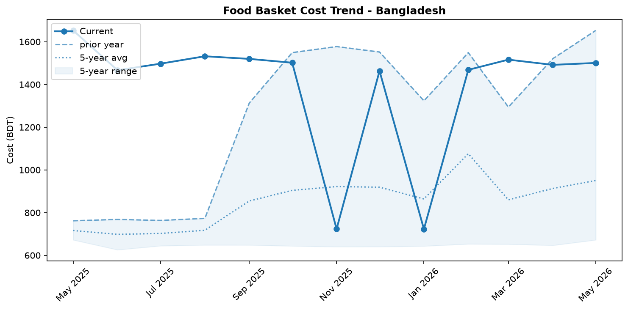
Food basket cost trend

Market Overview
The Bangladeshi food market exhibited significant volatility in May, with the price of the overall food basket remaining deceptively stable, rising by a mere 0.6 percent month-on-month. This stability masks powerful and opposing price movements within key commodities. Sharp monthly price decreases in essential items, notably onions (-23.6%) and chickpeas (-17.0%), exerted strong downward pressure on the basket. However, this was almost entirely offset by a substantial short-term price shock in eggs, which surged by 16.1 percent.
From a long-term perspective, the market continues to follow a deflationary trajectory. The overall food basket is significantly cheaper than a year ago, driven by major price collapses in sugar (-52.3%), eggs (-33.2%), and chicken (-31.3%). This annual deflation persists despite a gradual year-on-year depreciation of the Taka (0.45%), which typically exerts upward pressure on the cost of imported goods. The current market instability, characterized by simultaneous, sharp price increases and decreases in staple foods, points to an uncertain outlook. The trajectory in the coming month will depend on whether these divergent commodity trends reverse, stabilize, or continue to counteract each other.

Commodity Analysis
May's commodity price movements highlight a deeply fractured and volatile market. Several key items drove significant deflation. Onion prices plummeted by 23.6% from April, while chickpeas saw a similarly sharp decline of 17.0%, accelerating their year-over-year downward trend. Chicken and sugar remain major long-term deflationary drivers; chicken prices fell another 3.8% month-on-month (-31.3% YoY), and sugar, having collapsed 52.3% over the past year, has now stabilized with a marginal 0.2% monthly increase.
In stark contrast, eggs experienced a major price shock, surging 16.1% in a single month. This dramatic short-term increase runs counter to the longer-term trend, with egg prices still remaining 33.2% below last year's levels. This particular volatility underscores the market's current instability. Meanwhile, chili (Indian Teja) continues to be a primary source of inflation within the food basket. Its price climbed another 3.1% in May, contributing to a substantial 31.0% increase year-over-year. This sustained upward pressure on an imported staple, exacerbated by the slowly depreciating Taka, contrasts sharply with the price drops seen in other commodities, painting a complex picture for household food budgets.
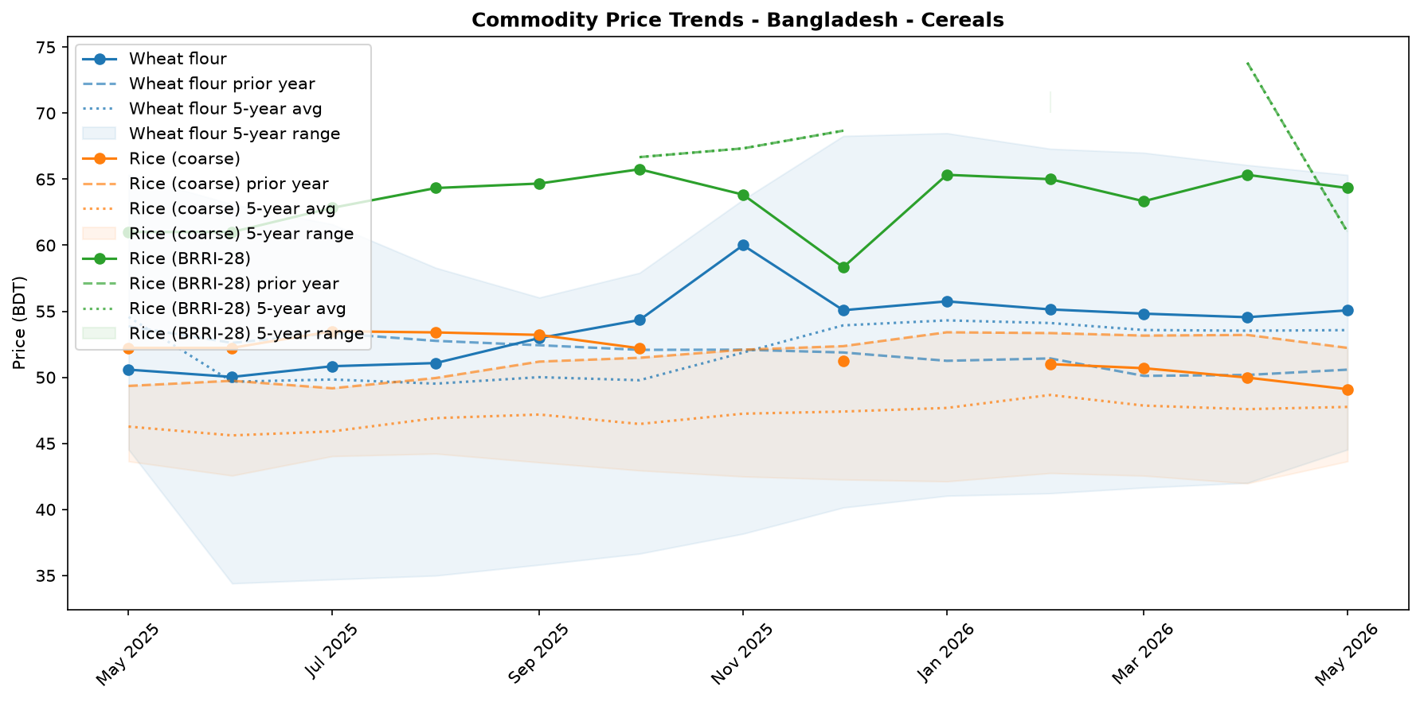
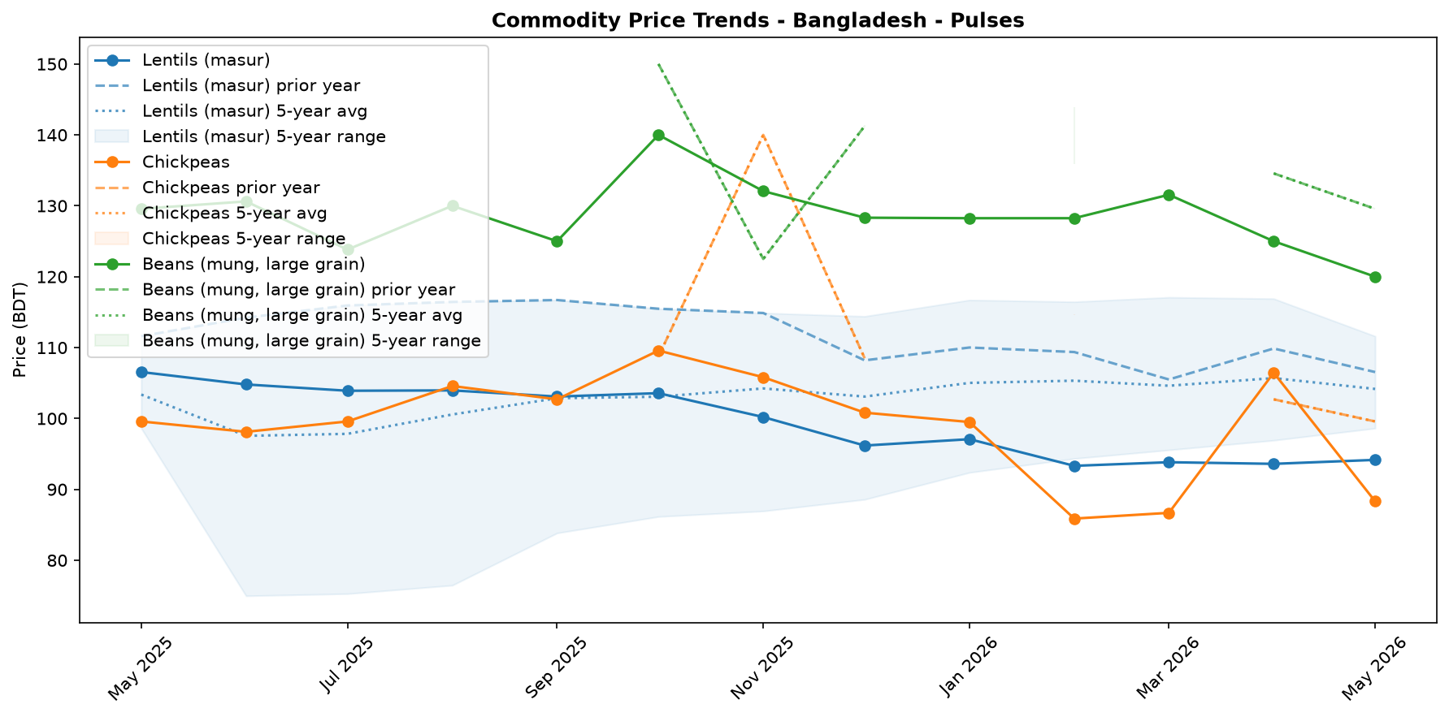
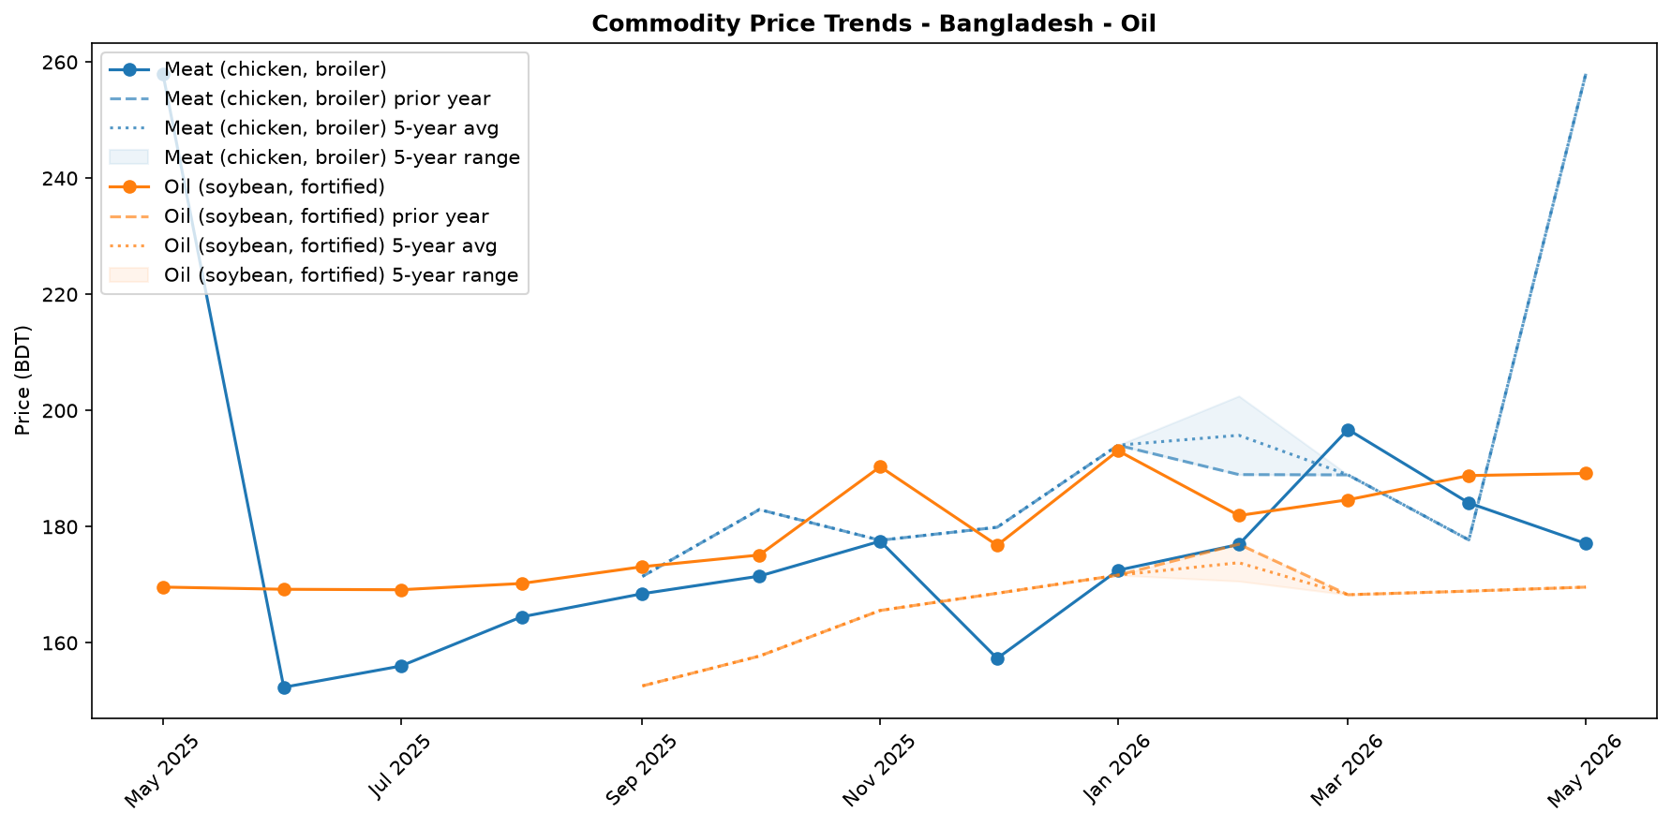
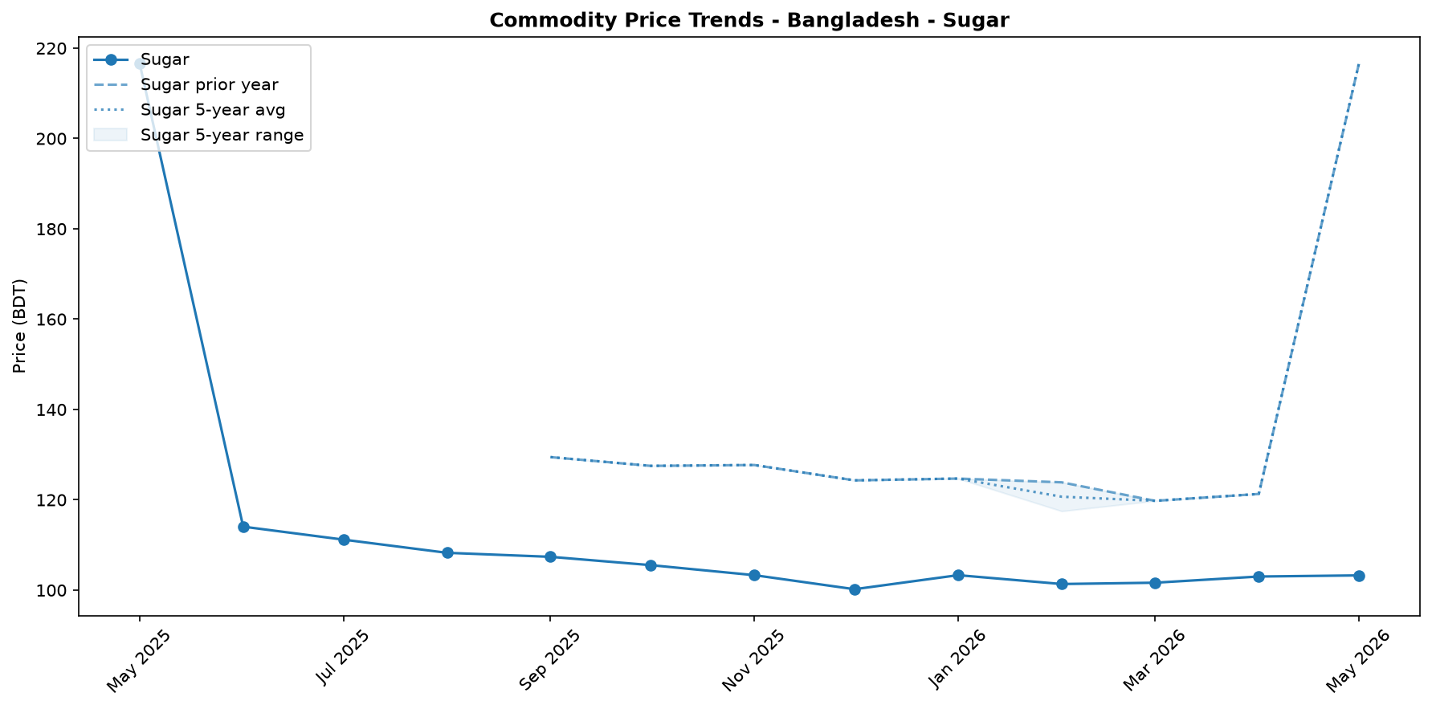
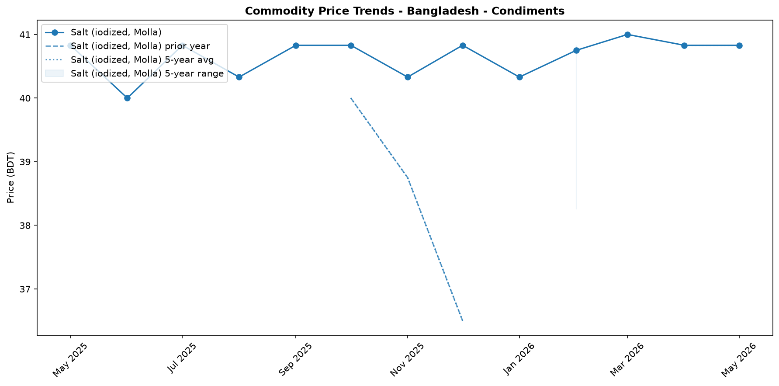
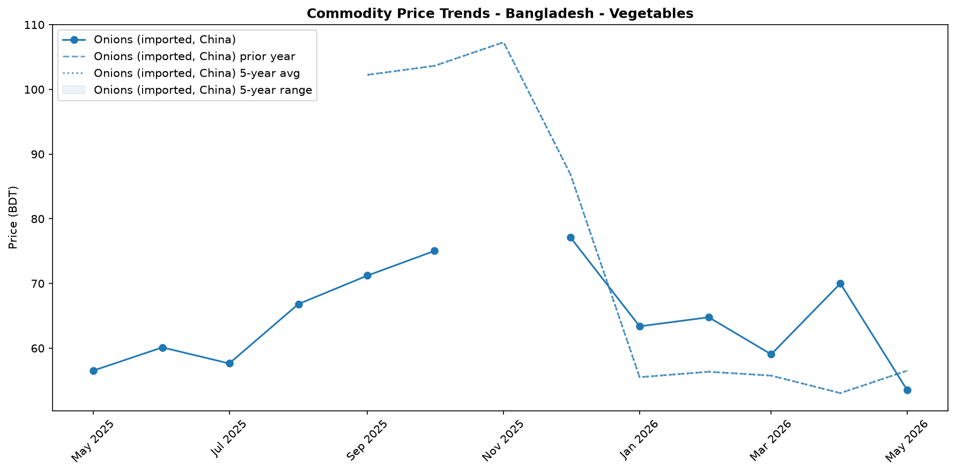


Regional Highlights
The analysis presented in this monitor is based on a single national food basket, as disaggregated regional data was not available for this reporting period. Consequently, the national average may not fully capture the diverse market conditions across different divisions of Bangladesh. Price volatility and food access can vary significantly between major urban centers like Dhaka and more remote, climate-vulnerable, or economically stressed regions.
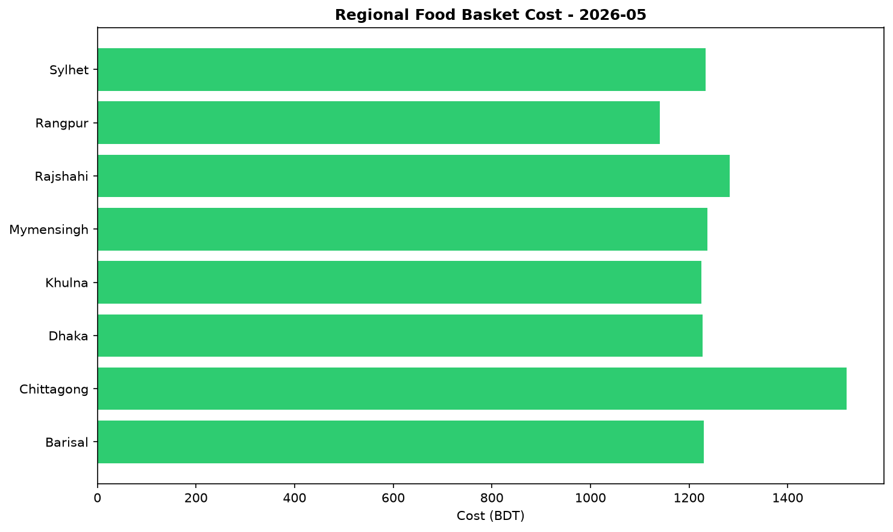
For instance, the economic landscape in Cox’s Bazar, which hosts the world's largest refugee camps, is unique. The recent UN appeal for USD 710.5 million to support refugees and host communities underscores the specific economic pressures in the area. Furthermore, environmental factors, such as deforestation-related landslide risks in the camps, can disrupt local supply chains and impact prices in ways not reflected in national data. International support, such as the EUR 2 million contribution from Finland for refugee resilience, also influences the local economy. A more granular, regional price analysis is crucial to better understand these localized dynamics and their impact on food security for the most vulnerable households.

EXCHANGE_RATE Analysis
The Bangladeshi Taka (BDT) remained relatively stable, trading at 122.75 per USD. The currency experienced a marginal month-on-month depreciation of 0.04 percent, a change too small to significantly alter the cost of imports in the immediate term. However, the longer-term trajectory points towards a gradual weakening, with the BDT having depreciated by 0.45 percent on a year-on-year basis. This persistent, albeit slow, depreciation trend exerts upward pressure on the domestic prices of essential imported commodities. The cost to procure key items like wheat, cooking oil, and fuel in local currency increases, which can translate to higher retail prices. This could also affect the cost of imported rice used for market stabilization, potentially impacting food security for the most vulnerable households who rely on these staples.

References
- [rw_4214182] ReliefWeb (2026-05-31) Finland boosts support for Rohingya refugees with EUR 2 million contribution [EN/BN]
https://reliefweb.int/node/4214182
- [rw_4214118] ReliefWeb (2026-05-29) Period poverty: A global menstrual health crisis
https://reliefweb.int/node/4214118
- [rw_4213869] ReliefWeb (2026-05-28) Asia and the Pacific: Weekly Regional Humanitarian Snapshot (19 - 25 May 2026)
https://reliefweb.int/node/4213869
- [rw_4213682] ReliefWeb (2026-05-26) Homestead Gardening Guidelines - Vegetable production for household consumption using minimal space in Rohingya camps and host communities
https://reliefweb.int/node/4213682
- [rw_4212820] ReliefWeb (2026-05-20) UN and partners appeal for USD 710.5 million to meet the critical needs of Rohingya refugees and Bangladeshi host communities [EN/BN]
https://reliefweb.int/node/4212820
- [rw_4212682] ReliefWeb (2026-05-19) From coverage to prioritisation: how funding cuts are reshaping operational decisions in Cox’s Bazar
https://reliefweb.int/node/4212682
- [rw_4212292] ReliefWeb (2026-05-15) Impact of gardening and nutrition support provided to women in refugee camps in Cox’s Bazar
https://reliefweb.int/node/4212292
- [rw_4212129] ReliefWeb (2026-05-14) Mr. Tom Fletcher, Under-Secretary-General for Humanitarian Affairs and Emergency Relief Coordinator – Remarks to the press on US humanitarian funding at UN Headquarters, 14 May 2026
https://reliefweb.int/node/4212129
- [rw_4212067] ReliefWeb (2026-05-14) Sweden announces more than SEK 2.7 billion in humanitarian assistance to the world’s most vulnerable
https://reliefweb.int/node/4212067
- [rw_4211766] ReliefWeb (2026-05-13) UNHCR Regional Bureau for Asia and Pacific: Myanmar Situation Update (Bangladesh, India, Indonesia, Malaysia, Myanmar, and Thailand) January - March 2026
https://reliefweb.int/node/4211766
- [seerist_1028666] Seerist (2026-05-22) Tiger kidnaps to remain rare despite incident involving bank manager in Dhaka district
- [seerist_1028464] Seerist (2026-05-08) Big Picture series: Keep calm and kharif on – fertiliser shock and political risk in South Asia
- [seerist_1028203] Seerist (2026-04-17) Operational, integrity risks to persist in renewable energy sector despite government support
- [seerist_1028169] Seerist (2026-04-16) Political interference, integrity risks likely to remain prevalent in banking sector despite reforms
- [seerist_1028140] Seerist (2026-04-14) Uneven enforcement of new labour law will sustain reputational, unrest risks in manufacturing
- [seerist_1028118] Seerist (2026-04-13) Big Picture series: Asian economies face prolonged energy stress as Middle East disruption persists
- [seerist_1028051] Seerist (2026-04-07) Civil unrest risks to increase amid differences over political reforms

